freETarget
Application Note: Assembling freETarget Competition II

CAUTION
The flatpack is made from unfinished wood.

- Wear eye protection
- Use caution when assembling to avoid splinters

When using freeTarget:

- Wear eye protection
- Maintain a safe distance
- Do not shoot into any areas except the open target areas.

The freeETarget project or contributors will not be responsible for any injuries when using this target of it’s components.

Target shooting can be dangerous so apply caution in everything you do.

SUMMARY
This document provides the instructions for assembling the freeETarget Competition target

REQUIRED
- Flatpack
- Wood Glue
- Hand tools
  - 2mm Allen key
  - 3mm Allen key
  - Small flat head screwdriver
  - Small Philips screw driver
  - Pliers or nut driver
  - 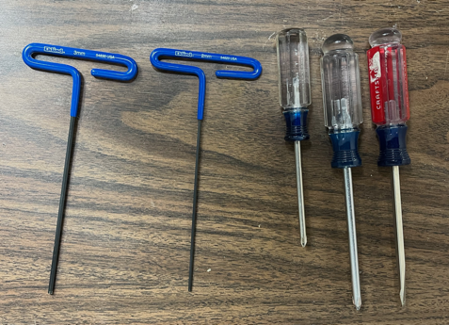
- Patience

INTRODUCTION
freETarget is an open source project to provide shooters with a low cost electronic target. To simplify the construction, the FreeETarget Flatpack was created to provide a single location for the mechanical construction.
The latest CAD files can be found at Github.com/ten-point-nine/freeetarget in the mechanical/cnc folder.
These instructions are for assemblies made after November 2022. Prior to that the screw assembly was not available and needed to be assembled with glue.
Assembling the flatpack is in five parts
- Assembling the back panel
- Assembling the frame
- Assembling the door
- Assembling the target plate
- Target assembly
PACKING SLIP
Item | Description | Quantity
 | Frame
1 | Top | 1
2 | Left with hinges installed | 1
3 | Right with magnets installed | 1
4 | Bottom | 1
5 | Back with sensor mounts and face plate bolts installed | 1
6 | Door | 1
7 | LED mounts | 4
8 | Witness paper mounts | 2
9 | Cable Guides | 3
 | Assembled Parts
10 | Witness paper drive with (qty) 4mm x 12 bolts | 1
 | Target Face
11 | Optional pistol face plate | 1
12 | Optional pistol target holder | 1
13 | Optional rifle face plate | 1
14 | Optional rifle target holder | 1
15 | 5mm mounting screws | 4
16 | Witness paper guide | 1
 | Piece Parts
17 | Screw Kit | 1
18 | Pierce Parts | 1

Assembling the Back Panel
1 | Back Panel with  - Sensor Mounts  - Witness Paper Mounts  - Cable Guides | 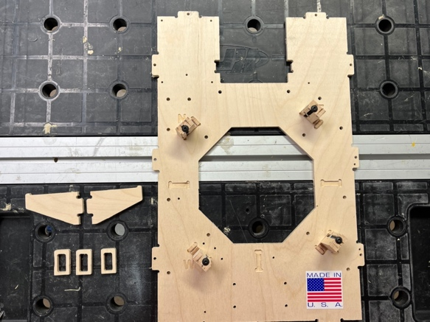
2 | Install the witness paper mounts, 2x using wood glue | 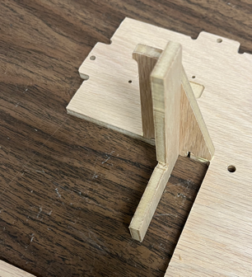
3 | Install the signal processor board | 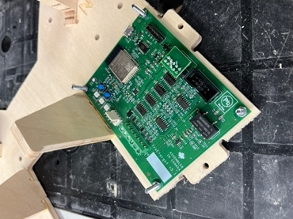
4 | Install the cable guides to the back panel using wood glue  There are three cable guides that fit into the slots on the back panel | 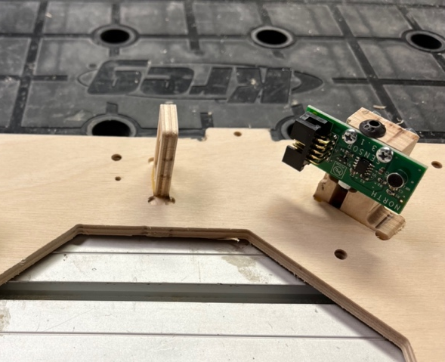
5 | Install the four sensors to the sensor mounts.  Make sure that the sensors (ex North) match the mount (ex N)  Install the sensor covers on the West and South sensors | 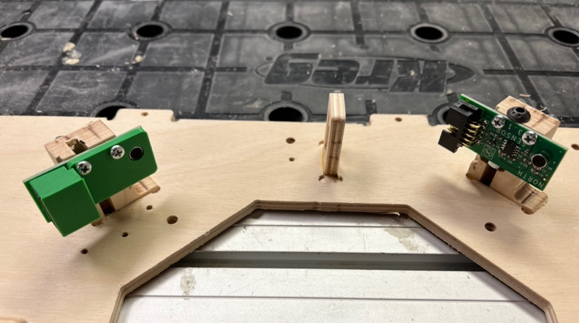
6 | 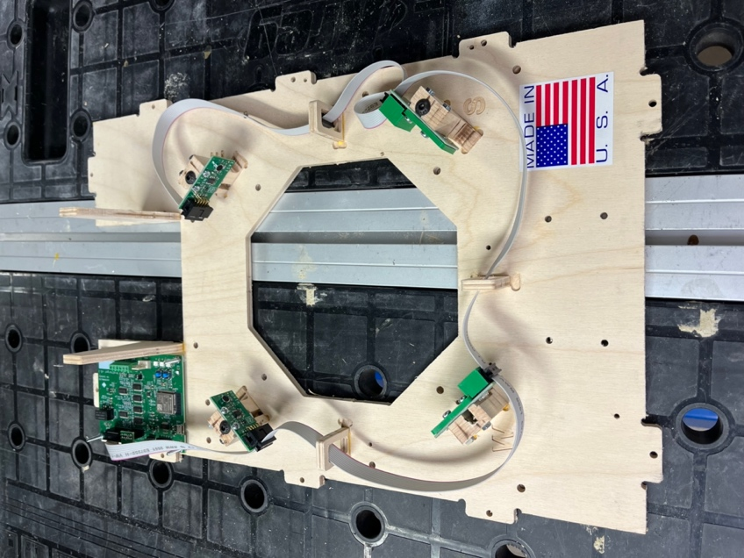 | Install the cable harness between the ESP32 board and the four sensors.  If the sensors don’t connect easily, reverse the order of the cable.  The Face connector (between South an East) is unused and is provided for rapid fire installations.
B | 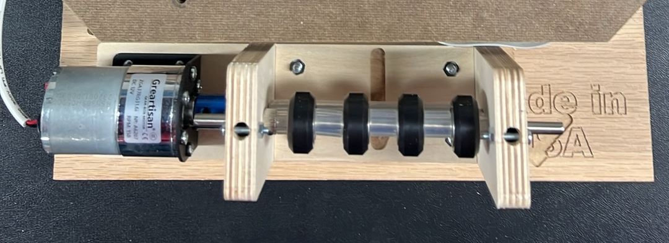 | Mount the circuit using the 25mm screws  Attach the witness paper drive  Install the USB Cable (not shown) to the circuit

Assembling the Frame
1 | Locate and identify the four frame parts,  Top  Bottom  Left  Right | 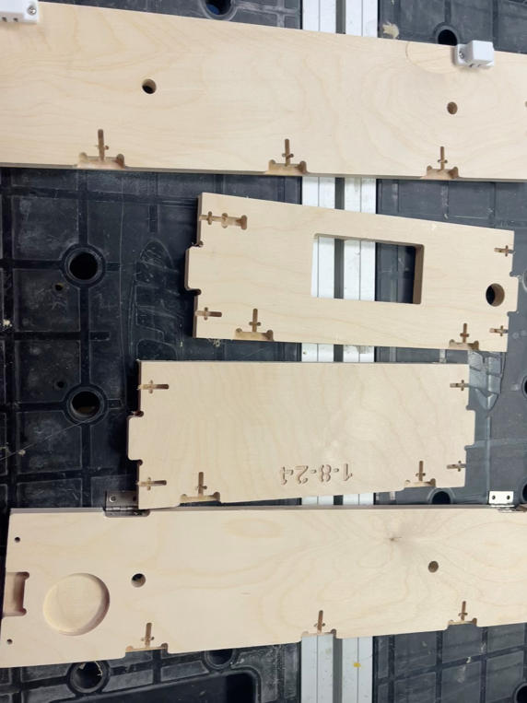
2 | 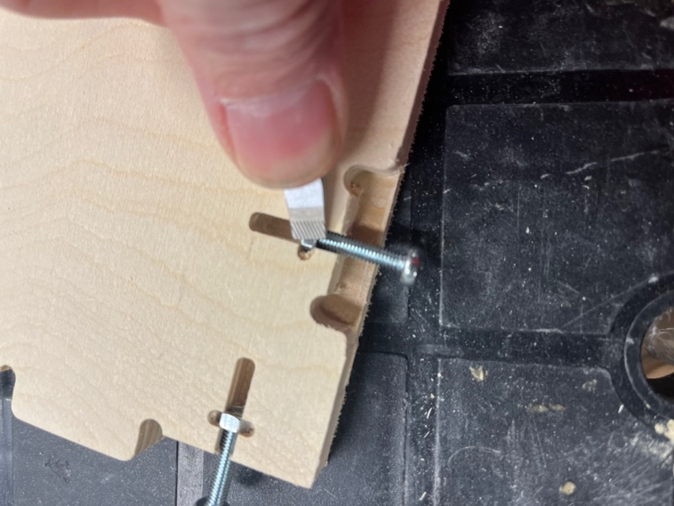 | In each of the slots, insert a 4mm nut.  Holding the nut with a screw and pressing in with a hard object will make the job easier
3 | 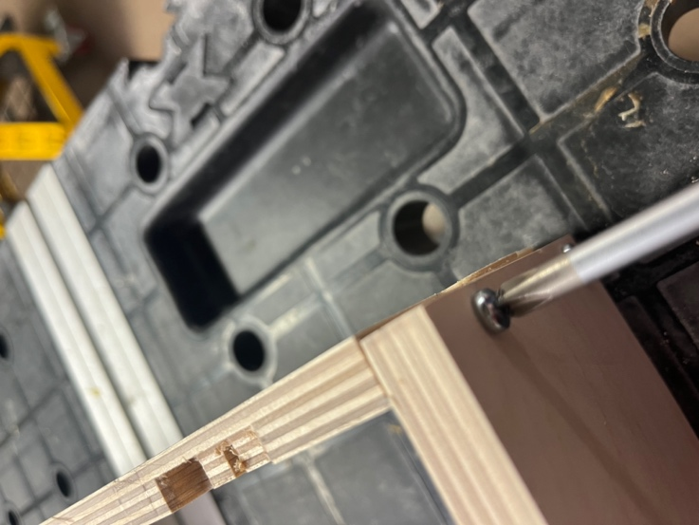 | Carefully push the side panels onto the back using the 22mm screws and nuts to hold in place.  Do not tighten at this time  You may need to use a screwdriver of knife to push the nuts all the way in place to get a good fitting.
4 | Repeat the process for attaching the top and bottom panels. | 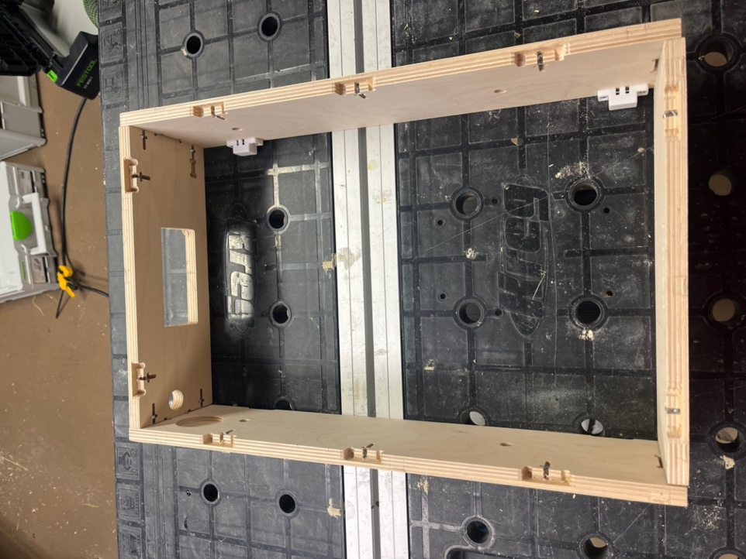
7 | 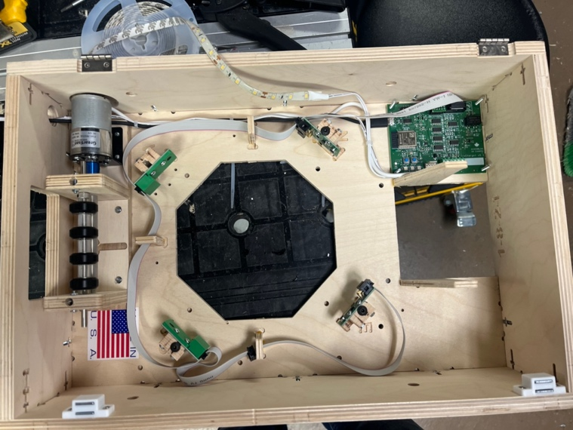 | Drop the back panel into the frame and hold in place with 22mm screws
8 | 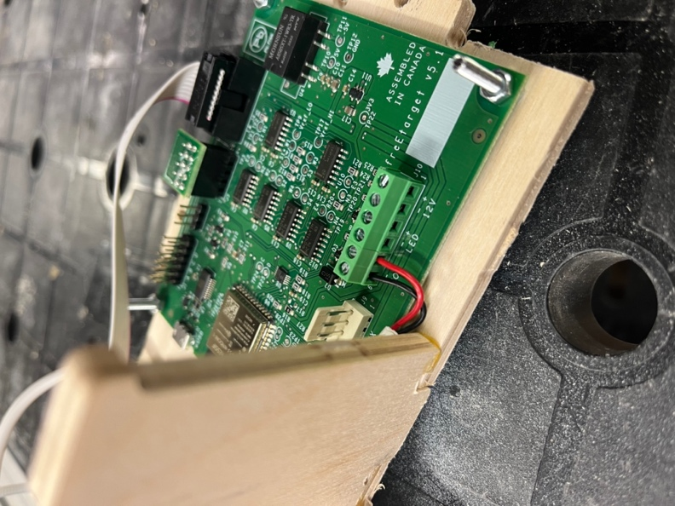 | Attach the motor drive, LEDs, and 12V supply to the screw terminals.  Pay careful attention to the positive and negative markings on the board and the wiring

Assembling the Face Plate
1 | Install the paper guide using the ½” wood screws.  Note the orientation of the two mounting screws on the right of the paper | 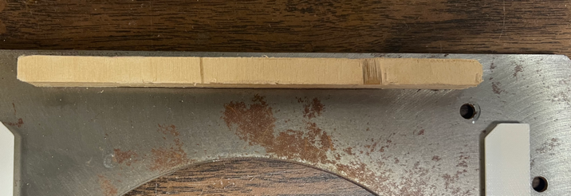
2 | Using the 3mm x 5 screws, attach the target paper guide onto the face plate.  Insert the screws, but do not tighten completely.  Tighten starting from the bottom two screws and work bottom to top.  Snug the screws, but do not overtighten. The target paper guide is made from 3D printed plastic and will strip the screws if overtightened. | 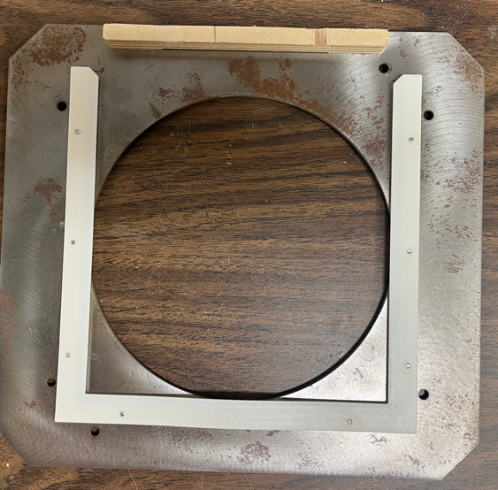
5 | 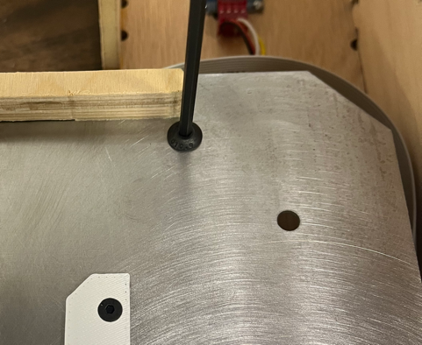 | Flip the face plate onto the base and attach with the long 5mm screws.  Do not overtighten

Installing the Door
1 | Glue the LED mounts in place (4x) | 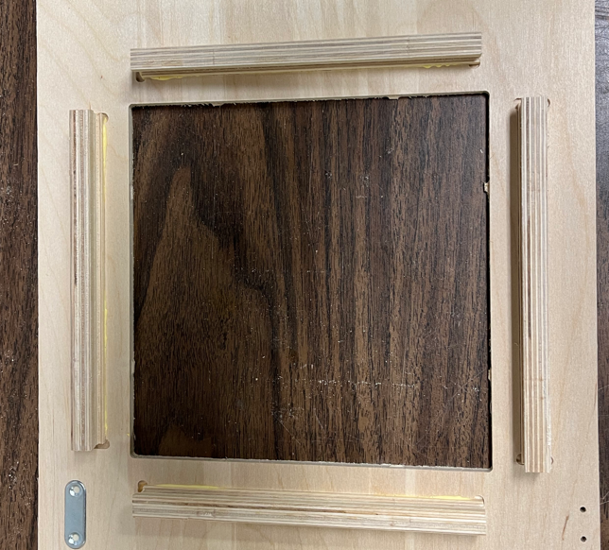
2 | Attach the door to the hinges using the countersunk 3mm screws | 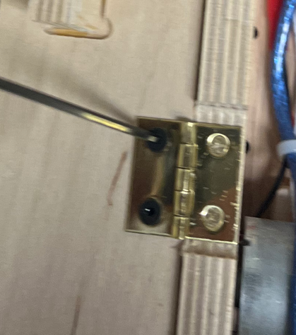
3 | Install the LED light strip  Remove the release paper and tape to the LED mounts.  From the open position,  Start Bottom Right  Wind in counter clockwise direction | 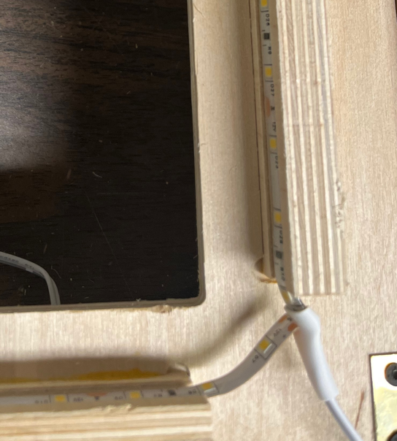
4 | Finish connecting the LEDs if you have not done this before.

DOWNLOADING AND INSTALLING PC SOFTWARE
Click the link below to go to the downloads page
https://free-e-target.com/downloads/
Look for the PC Software section and download the software (Figure 9)
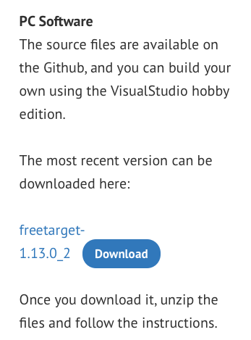
Figure 9: Download Software

Unzip the software and install on your PC.
Connect the USB cable between the target holder and the PC.

DOWNLOADING AND INSTALLING PYTHON SOFTWARE
Version 5 hardware uses a new processor that requires additional software if you need to update the software in the target.
Visit https://www.python.org/downloads/ and select Download Python (version)

DOWNLOADING AND INSTALLING ESP32 SOFTWARE
- From the Windows startup box, launch a command prompt
- Install the ESP tools for Python by typing pip install esptools

STARTING UP
Launch the PC program and look for the setup icon (GEAR WHEEL) in the upper right corner (See Figure 10)
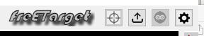
Figure 10: Setup Icon Location

Enter all of the setup information needed in Figures 9, 10, 11, and 12
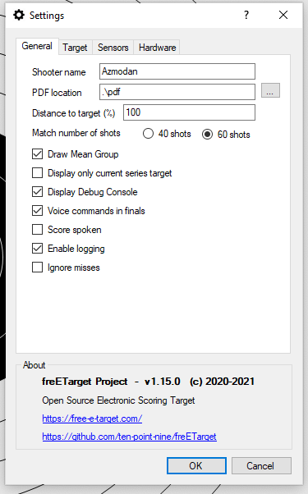 | 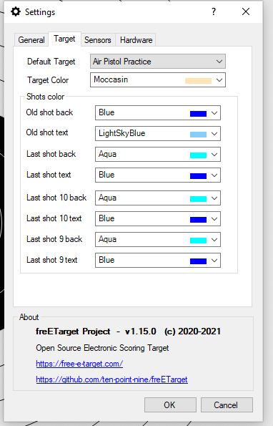 | 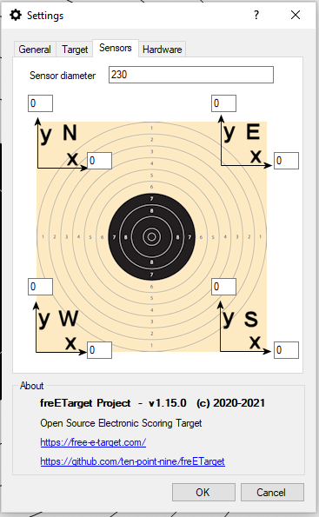 | 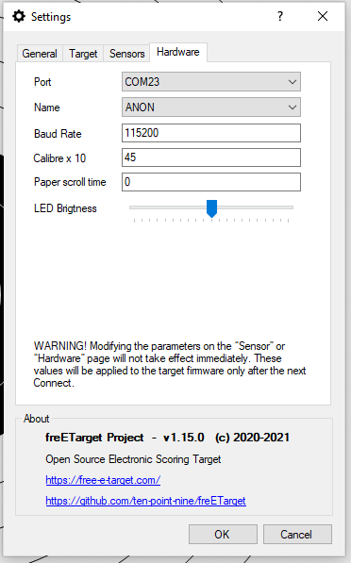
Figure 11: General Settings | Figure 12: Target Settings | Figure 13: Sensor Adjustment | Figure 14: Hardware Interface

Figure 11: This allows you to enter the shooter name and how information will be stored.
Figure 12: Choose the target you will be shooting against and the colours you will be using.
Figure 13: Fine tune the sensor position to adjust for assembly errors
Figure 14: Interface to the target hardware.

Press 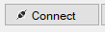 to begin a session.

Refer to the Commissioning Instructions from the web site. This will give you a quick summary of how the system is working
TROUBLESHOOTING
The boards are tested before shipment, but a lot can happen between the last test and the first shot. If your system is not working, please follow the trouble shooing guide below before sending an email to freETarget.com
PC Program complains “Database Check Fails..: | - Security issue with some antivirus software  - Try running as administrator  - Disabling antivirus
PC Program cannot see target | - The Arduino uses a CH340 which may not have a driver on your PC  - Follow the instructions at https://sparks.gogo.co.nz/ch340.html to load in the correct driver
No Shots Registered | - Check that the USB cable is attached  - Check that the correct Serial port is set in the setup  - Check that the wiring harness is attached to all of the sensors  - Tap each of the sensors. Do the three LEDs blink?
Shots show up but in the wrong place | - From the firing line, shoot a blank shot  - Do the three LEDs blink?  - Yes, set a new trip point  - No, Check all of the wiring  - Verify that the sensors North – West are in the correct order
The shots show up but rotated 90 degrees | - Verify the order of the sensors and correct
The shots are the mirror image left-right | - The sensors are reversed. Switch the positions of NORTH-EAST and SOUTH-WEST

APPENDIX A – freETarget Components
